Predicting Community-Level Illness in Massachusetts Using Demographic and Civil Variables
Authors:
Joshua Stoltzfus, Derrick Toussaint
Each author contributed equally to the design, coding & development, analysis, and writing of this project.
Date: December 17th, 2025

Abstract
Chronic illness is unevenly distributed across communities, reflecting not only biological risk but also underlying social and structural risk. This project examined whether civil and demographic variables can meaningfully predict community-level illness burden across ZIP codes in Massachusetts. Using the 2019 Social Determinants of Health (SDOH) dataset published by the Agency for Healthcare Research and Quality (AHRQ), we constructed multiple representations of illness burden and applied a combination of unsupervised and supervised machine learning methods. Principal Component Analysis (PCA) applied to chronic illness indicators reveals two prominent dimensions of illness burden, while ensemble regression models are used to assess the predictive capacity of socioeconomic and civil variables. Results showed that demographic and socioeconomic factors exhibit strong predictive power for certain dimensions of illness. In contrast, biologically driven illness severity proves more difficult to predict using community-level proxies alone, as would be expected. Beyond predictive accuracy, this study emphasizes proper methodology and interpretability for potential socioeconomic policies. By explicitly modeling illness dimensions rather than a single aggregate outcome, the analysis demonstrates how public data and modern machine learning techniques can uncover actionable patterns in population health. These findings support the growing consensus that socioeconomic structures play a central role in shaping health outcomes and provide a framework for data-driven public health decision-making.

Background & Research Question
Health outcomes are increasingly understood as products of social, economic, and environmental conditions rather than solely individual behaviors or genetics. The World Health Organization (WHO) has argued that social determinants of health (SDOH) exert a greater influence on health equity than genetics, healthcare access, or personal choice alone. In the United States, the Centers for Disease Control and Prevention (CDC) defines SDOH as nonmedical factors (such as income, education, employment, and neighborhood environment) that shape health outcomes and life expectancy. Similarly, Healthy People 2030, a federal public health framework led by the U.S. Department of Health and Human Services, identifies SDOH as foundational conditions that structure population health disparities.
Despite the agreement on the importance of SDOH, the public health conversation is much more focused on individual-level behavior change or clinical risk management. This emphasis can obscure the role structural conditions affect entire communities and that are directly actionable through policy. Community-level analysis offers a complementary lens by examining how populations exposed to similar socioeconomic and infrastructural contexts experience patterned health outcomes. This project addresses this gap by modeling health outcomes at the ZIP-code level. ZIP codes, while defined by postal zones, and thus imperfect proxies for neighborhoods, have populations together that commonly share administrative, economic, and service-access environments, making them relevant units for public policy and resource allocation. And with this in mind we constructed our question, and hypothesis below.
Research Question:
To what extent can civil and demographic variables predict community-level illness outcomes across Massachusetts ZIP codes?

Hypothesis:
We predicted that civil and demographic variables would exhibit statistically meaningful predictive power for community-level illness outcomes, indicating that structural conditions are reflected in measurable health patterns.

Data
Exploratory analysis was conducted to assess distributions, relationships among illness indicators, and overall model suitability, with exploratory figures and tables produced and interpreted (see the Appendix). PCA explained-variance and loading tables demonstrated that a small number of latent components captured the majority of variance among chronic illness measures. Cross-validation performance tables showed that ensemble models exhibited stable generalization across folds. Residual scatter plots indicated reduced systematic error relative to simpler baseline models, while residual distribution histograms suggested approximate symmetry and limited skew in model errors. Q–Q plots further showed reasonable alignment, supporting the stability of the fitted models. Taken together, these methods of diagnostics showed that ensemble tree-based methods were well suited to the data structure and that additional tuning and boosting could provide incremental performance gains.

Preprocessing
Data preprocessing was designed to be replicable and methodologically transparent. Variables with extreme missingness (≥95%) or entirely missing values were removed prior to modeling. Remaining missing values were imputed using median imputation. Numeric predictors were standardized where appropriate as needed for the PCA and does not hurt Random Forest or Gradient Boosting performance. Multiple outcome representations were considered. An initial ZIP-level illness bucket score was constructed by standardizing illness variables and assigning quartile-based severity scores. This approach discretized illness severity and implicitly treated all conditions as equally severe. The final approach used Principal Component Analysis (PCA) applied to chronic illness indicators. PCA preserved continuous variation, differentiated illness dimensions based on shared variance structure, and produced more informative outcomes. PCA-based outcomes ultimately yielded stronger and more stable predictive performance and were prioritized.

Model Selection
Random Forest and Gradient Boosting regression models were selected due to their ability to handle nonlinear relationships, multicollinearity, and interaction effects in high-dimensional structured tabular data without requiring strong parametric assumptions. These properties align well with the structure of SDOH data. Model limitations were explicitly considered. Ensemble models can exhibit biased feature importance under collinearity and are susceptible to overfitting. These risks were monitored using cross-validation, test-set evaluation, and comparison of training versus testing performance.

Final Model and Evaluation
Model tuning and validation were evaluated using repeated 5-fold cross-validation and a held-out test set, with performance assessed via mean absolute error (MAE), root mean squared error (RMSE), and R² to capture complementary aspects of predictive accuracy. Across all outcomes, models predicting PC2 (the socioeconomic–behavioral health dimension) consistently outperformed those predicting PC1 (biological illness dimension), exhibiting lower error and stronger generalization. Untuned Random Forest models achieved strong cross-validated performance for PC2 (R² ≈ 0.90) with relatively low variance across folds, while PC1 models showed signs of overfitting, evidenced by very high training R² (>0.98) but substantially lower test-set R² (≈ 0.60). Hyperparameter tuning improved stability for both outcomes, but a similar performance gap remained. Tuned PC2 models achieved test-set R² values above 0.92 with reductions in MAE and RMSE relative to untuned baselines, whereas tuned PC1 models showed only modest gains and continued generalization limits. Gradient Boosting models slightly outperformed Random Forests on PC2 across all three metrics, yielding the lowest MAE and RMSE and the highest cross-validated R² (≈ 0.90), while maintaining strong test-set performance (R² ≈ 0.93). Residual diagnostics (including residual scatter plots, residual distributions, and Q–Q plots) were examined for each model and are provided in the Appendix. Taken together, the tuned Gradient Boosting model predicting PC2 emerged as the best overall model, balancing high explanatory power, low prediction error, and stable generalization, while results for PC1 underscore the limits of predicting biologically driven illness severity using community-level demographic proxies alone.

Conclusions
This study demonstrates that civil and demographic variables can and do meaningfully predict certain dimensions of community-level illness across Massachusetts ZIP codes. Structural socioeconomic conditions are not merely correlated with health differences; they are sufficiently informative to support predictive modeling using publicly available data. These findings align with prior SDOH literature emphasizing the central role of structural conditions in shaping health outcomes, while extending this work by demonstrating predictive measurability at the ZIP-code level. At the same time, weaker generalization for biologically driven illness severity highlights the limits of demographic proxies and underscores the importance of aligning modeling goals with underlying mechanisms.

Discussion & Next Steps
This framework can inform targeted public health initiatives by identifying ZIP codes where structural conditions predict elevated access-related and behavioral health burdens. Future work could incorporate finer geographic resolution to strengthen patterns and causal inference.

Code Availability
All code used in this project is available at: https://github.com/toussaintd-web/DSE6311_Repository
The repository contains modular scripts, documentation, and environment specifications to ensure reproducibility. This open approach supports transparency, collaboration, and long-term sustainability of the analysis.

Appendix:
Residual Plot: This plot shows the distribution of residuals across fitted values for either the untuned or tuned Random Forest Model or Gradient Boosting model. This is indicating substantial unexplained variability and reinforcing that biological illness severity is less predictable using the available demographic and socioeconomic features.

Residual Distribution: This histogram illustrates the distribution of prediction errors for either the untuned or tuned Random Forest Model or Gradient Boosting model, showing the broad spread of residuals that further indicates limited predictive accuracy for biological illness severity.

Q-Q Plot of Residuals: For either the untuned or tuned Random Forest Model or Gradient Boosting model, the Q–Q plots compare model residuals to a theoretical normal distribution. Close alignment with the reference line suggests reasonable adherence to normality assumptions for error behavior

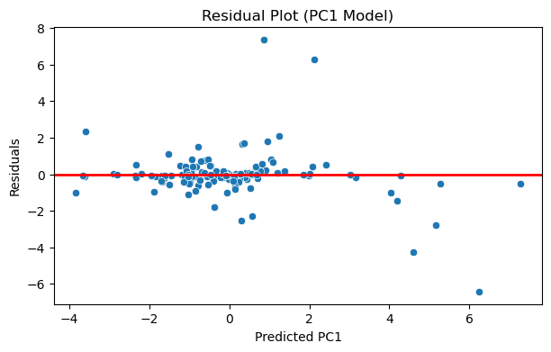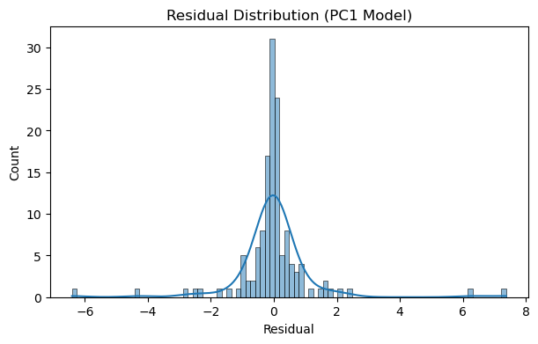
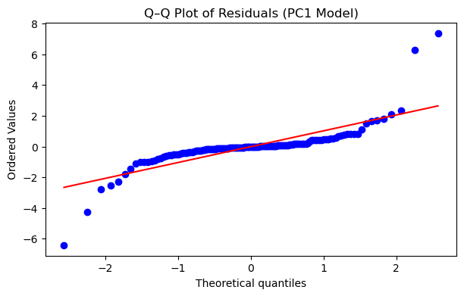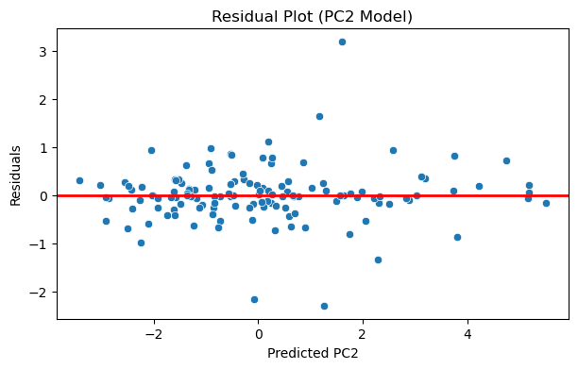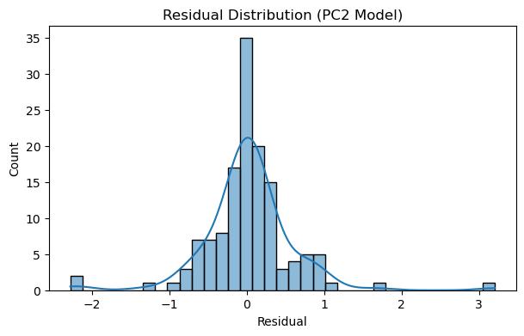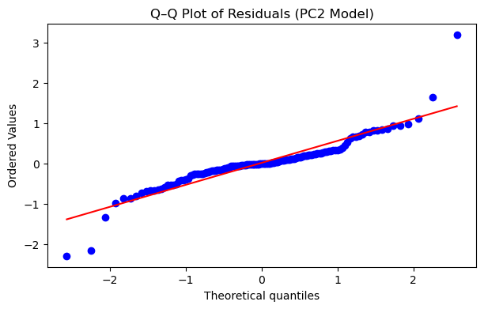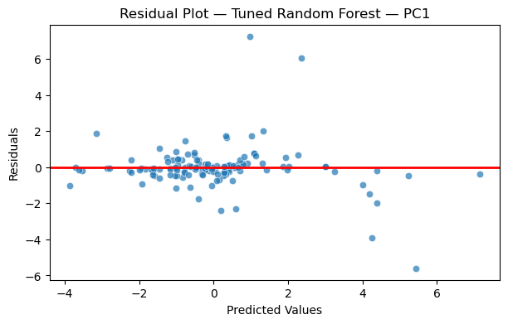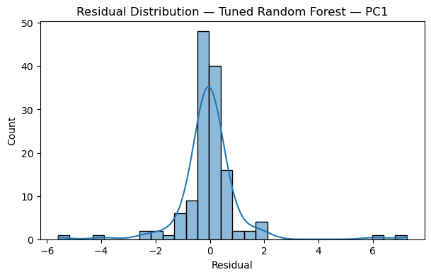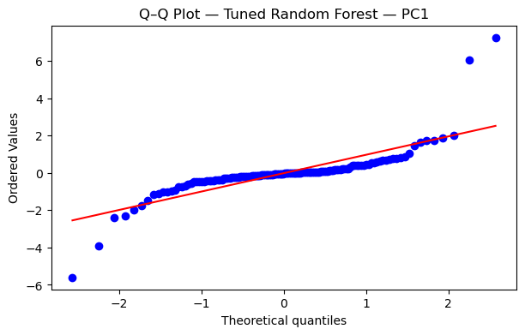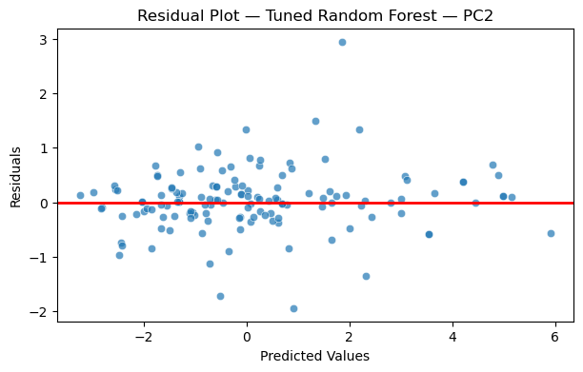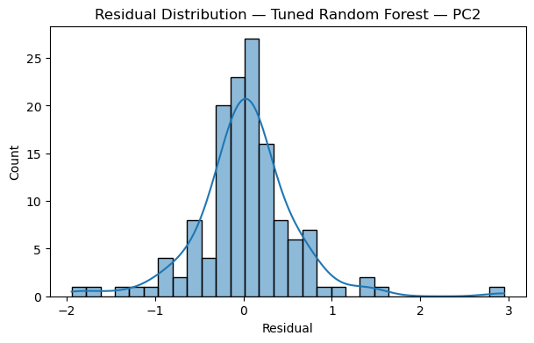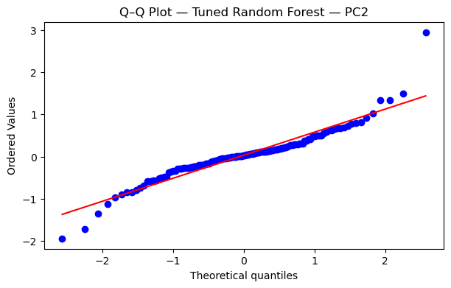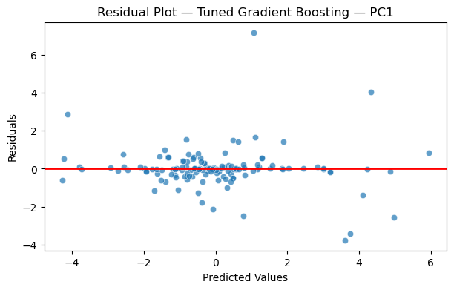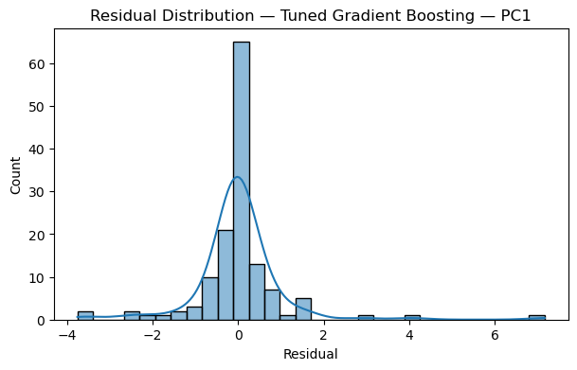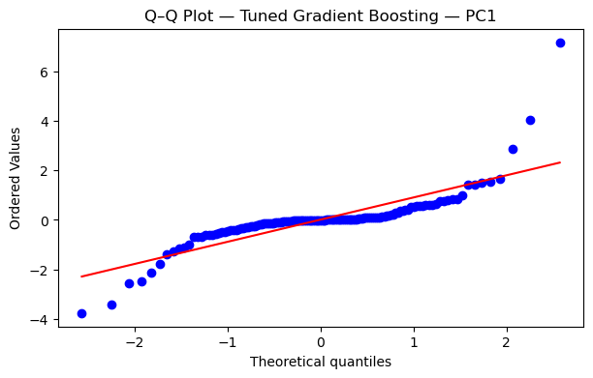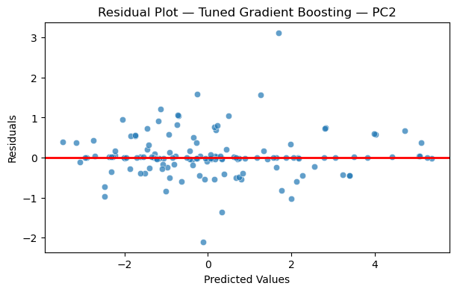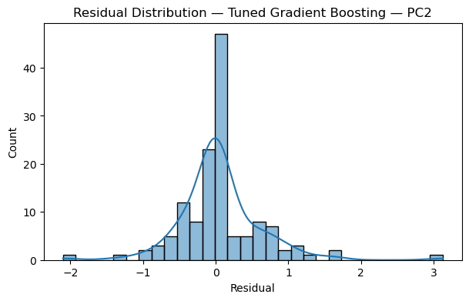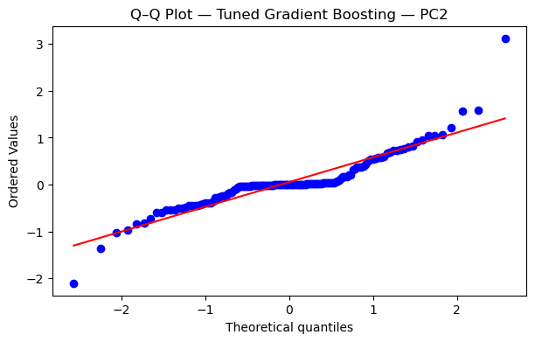

Citations

SDOH Data and Analytics | Agency for Healthcare Research and Quality, www.ahrq.gov/sdoh/data-analytics.html.
DR;, Braveman P;Egerter S;Williams. “The Social Determinants of Health: Coming of Age.” Annual Review of Public Health, U.S. National Library of Medicine, pubmed.ncbi.nlm.nih.gov/21091195/.
Chetty R;Stepner M;Abraham S;Lin S;Scuderi B;Turner N;Bergeron A;Cutler D; “The Association between Income and Life Expectancy in the United States, 2001-2014.” JAMA, U.S. National Library of Medicine, pubmed.ncbi.nlm.nih.gov/27063997/.
“Michael Marmot.” Wikipedia, Wikimedia Foundation, 5 Dec. 2025, en.wikipedia.org/wiki/Michael_Marmot.
Social Determinants of Health (SDOH) Database AHRQ Social Determinants, www.ahrq.gov/sites/default/files/wysiwyg/sdoh/SDOH-Data-Sources-Documentation-v1-Final.pdf.
“Social Determinants of Health.” Wikipedia, Wikimedia Foundation, 15 Dec. 2025, en.wikipedia.org/wiki/Social_determinants_of_health.

https://www.who.int/teams/social-determinants-of-health/equity-and-health/world-report-on-social-determinants-of-health-equity
https://www.cdc.gov/health-equity-chronic-disease/social-determinants-of-health-and-chronic-disease/index.html
https://odphp.health.gov/healthypeople/priority-areas/social-determinants-health

